Python Login Program

Report

COHDSE182f006 – S. M. Lagamuwa

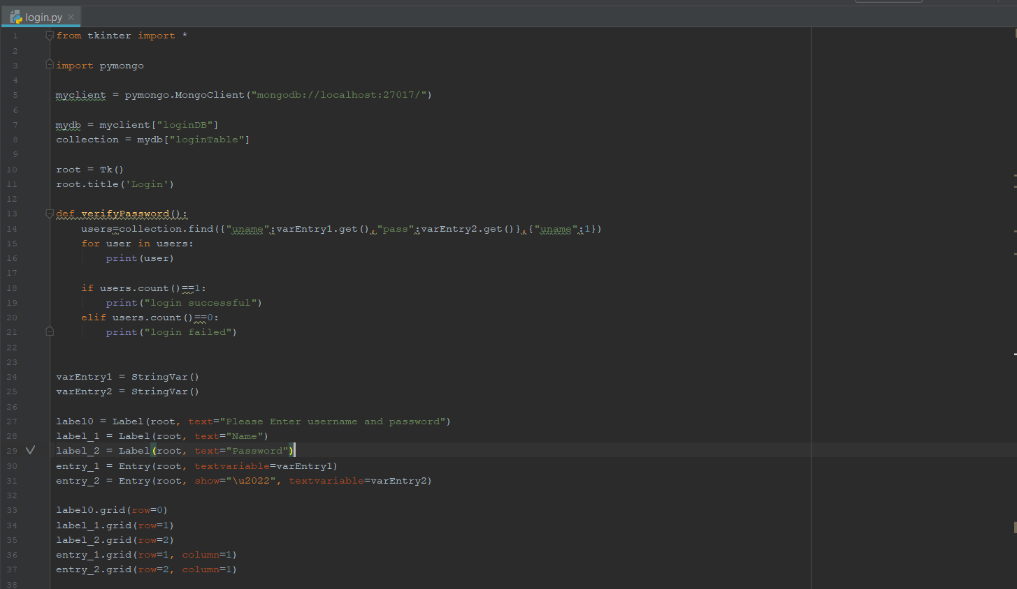

Uses pymongo as driver

In query , passes user inputs for username and password into the database and returns the username.

If row count is 1, username password verified.

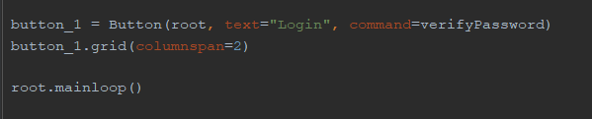

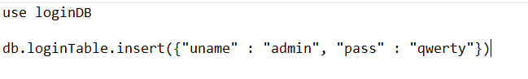

Mongo db insert query